ADR009622
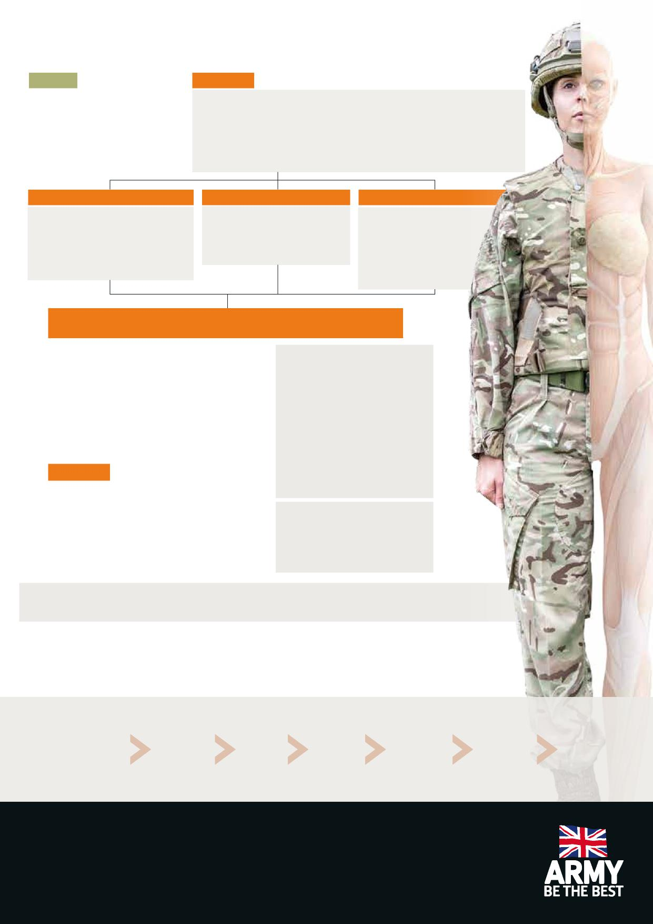
BREASTFEEDING
DIRECT
INDIRECT
You may be able to coordinate with your CofC to feed baby during the day depending on your job role; this would usually involve travel away from the workplace rather than bringing a baby in to the workplace.
Employers are legally required to provide somewhere safe for pregnant and breastfeeding
women to rest that is not a toilet/changing room.¹
Where it is possible Defence are committed² to supporting women to express milk at work.
A suitable environment would include storage facilities for milk, somewhere to wash your hands
with clean water and you will also need your personal equipment.
Defence is committed to helping women to continue breastfeeding on return to work, breastfeeding
is not a medical issue and downgrading solely for breastfeeding is not usually required.
HAND EXPRESSION
MANUAL BREASTPUMP
ELECTRIC BREASTPUMP
Good if your breasts become engorged as
can be done at any time.
Free.
Can take longer.
No equipment or power needed.
Can take time to learn how to do it effectively.
The quickest way to express. More efficient. Can be more expensive. Simple to use.
Faster than hand expression.
Can be cheaper.
Simple to use.
Lightweight.
Quieter than electric.
No power needed.
GET COMFORTABLE | DONT RUSH | RELAX
- Prep your kit- wash your hands.
- Massaging your breast for a few minutes can help with the let-down reflex.
- Look at a photo/video of your baby to help your let down.
- Start slowly or with a slow speed setting. It may take a few minutes before your milk starts flowing, once it does you can increase the speed.
- Switch breasts when your milk starts slowing down. One breast may produce more milk than the other, don’t worry! This is completely normal.
STORAGE
Planned activities requiring separation eg courses, deployments, exercises.
You can still breastfeed whilst away. Options to maintain your milk supply include; arranging refrigerator storage; using cool bags and freezer packs to transport milk back home or 'pump and dump'. In many cases arranging a freezer stash before you go can also help.
For longer courses discuss with the CofC how you can manage your BF needs.
Breast milk can be stored in a sterilised container, or special
storage bags – remember to label and date it. Store it in small
quantities to avoid wasting any. Breast milk can then be kept:
- At room temperature for no more than 6 hours (if the room temperature range remains 19-26 C, otherwise 4 hours)
- At the back of the fridge, not the door, for up to 6 days (at 4°C or lower)
- In the freezer for up to 6 months
Exclusive breastfeeding is not always effective contraception; please see the contraception poster or your medical centre for advice on the best method for you.
STAGE PUMPING
COMFORT
BREAKS BREAKS
ADDITIONAL STORAGE BREAKS
COURSE, EXERCISE,
DEPLOYMENT CONSIDERATIONS
OTHER
CONSIDERATIONS
9-12 months 2 breaks of roughly 30-45 minutes
in an 8 hr day
Frequent reviews as breastfeeding patterns and infant requirements change during this period
May need 1-2 5 minute breaks when changing patterns
to relieve engorgement
1-2 additional breaks of roughly 20-45 minutes
these may be required for up to 4 weeks before an agreed period of separation
May require forward planning to allow additional storage pumping and plans to be put in place.
May require a discussion about pumping and dumping depending upon course. May need to consider cessation (can take 8 weeks).
6-8 weeks before returning to work - use a KIT day to inform the CoC you wish to continue breastfeeding and ensure a breastfeeding plan is jointly agreed. CoC should review risk assessments to ensure they are appropriate.
RETURN
TO
WORK
1-2 weeks before returning to work, practise expressing.
If your child reaches the age of 2 and you want to continue to BF. Liaise with your CoC.
When the time comes, think about how you would like to stop.
On your RTW medical, inform the MO you are breastfeeding, this should not impact your medical grade.
As your child gets older, you may find your need to express reduces.
Keep your CoC in the loop.
Examples of a joint breastfeeding plan can be found in the updated Pregnancy, Maternity and Return to Work guide, this should be used to agree your own personal plan with your CofC.
¹ https://www.hse.gov.uk/mothers/law.htm
² JSP 375 Part 2 Vol 1 Chap 20

